**OVERVIEW OF THE NATURAL RESOURCES OF NIGER STATE**

1. **AGRICULTURE**

**FOOD CROPS FROM EACH ZONE IN NIGER STATE**

|  |  |  |  |
| --- | --- | --- | --- |
| **ZONE** | **LOCAL GOVERNMENTS** | **FOOD / CASH CROP** | **FOOD VALUE CHAIN** |
| A | Agaie  Bida  Edati  Gbako  Katcha  Lapai  Lavun  Mokwa | Rice | Rice flour and composite flour. |
| Groundnut | Oil for domestic, industrial applications, cake for animal feed and human consumption |
| (Sesame) Beniseed | High in Zinc content, the oil is good for domestic use, also high in vitamin ‘E’. |
| Cassava | Production of starch, Ethanol, use as bio-fuel, use in textile industry as a mordant, and in paper industry. |
| Potatoes | It can be process into *Kambar* |
| Sugarcane | Process into sugar, brown sugar and into local gin |
|  |  |  |  |
| B | Bosso  Chanchaga  Gurara  Munya  Paikoro  Rafi  Shiroro  Suleja  Tafa | Yam | Can be process into Pando flour, starch production |
| Bean | The shaft for animal feed, beans cake |
| Soybean | Process into cheese, soya milk, into condiments such as *Soya Iru* (*Dadawa*)oil for domestic use and industry. The cake for animal feed and Soya yoghurt. |
| Melon | Production of oil for industrial use, cake for animal feed and human consumption. |
| Barbara nut | To produce *Okp*a, composite flour for domestic application mostly in the baking sector |
| Jatropha species | For production of bio-fuel |
|  |  |  |  |
| C | Agwara  Borgu  Kontagora  Magama  Mariga  Mashegu  Rijau  Wushishi | Maize | Production of oil, ethanol and animal feed. |
| Share butter | The butter is to produce soap, cream, pharmaceutical products, for paint, oil emotion |

**PRODUCTION OF CROPS AND CASH CROPS PER HECTRE IN NIGER STATE**

|  |  |  |
| --- | --- | --- |
| **ZONE** | **FOOD CROPS** | **MT / H** |
| **A** | Rice  Maize  Sorghum  Millet  Cowpea  Soybean  **Root& Tuber**  Yam.  Cassava | 4 – 5  2 – 2.5  2 – 2.5  2 – 2.5  2 – 3  2- 2.5  15 – 25  15 -20 |
| **A** | **CASH CROPS** |  |
|  | G/nut.  Melon.  Sesame | 2 – 2.5  3 – 4  1 – 1.5 |
| **ZONE** | **FOOD CROPS** |  |
| **B** | Yam  Cassava  Soybean  Cowpea.  Sorghum  Maize | 20 – 30  15 – 20  2 – 2.5  1 – 1.5  1.5 – 2  2 - 3 |
|  | **CASH CROPS** |  |
|  | G/ nut  Cashew nuts  Shea nuts | 1.5 – 2  2 – 2.5  2 – 2.5 |
| **ZONE** | **FOOD CROPS** |  |
| **C** | Maize  Soybean  Rice.  Cowpea  Sorghum | 4.5 – 6  2.5 – 3  4 – 4.5  3 – 4  2 - 3 |
|  | **CASH CROPS** |  |
|  | G/ nut.  Cashew nuts  Shea nuts | 2 – 2.5  3 – 4.5  1 – 1.5 |

1. **MINERAL RESOURCES**

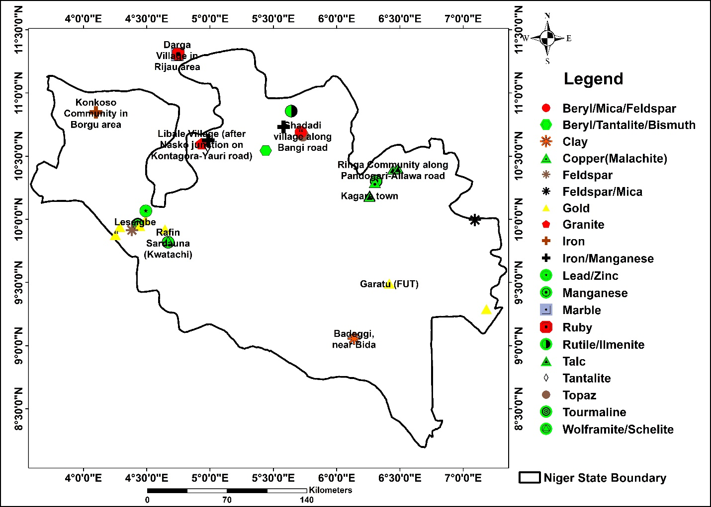

**Map of Niger State showing locations of some major mineral resources**

The main mineral occurences in the Niger State studied and assessed by the University include the follwoing;

1. **Gold**

Gold is one of the minerals that highly occurs and is mined in Niger State where it occurs in variety of forms in different geomaterials.

1. **Galena**

Galena deposit occurs on the bank of River Niger in Malale village. It is dark brown in colour, very dense and is hosted in quartzite. Nearly the whole area where it occurs has been submerged by the river. It probably occurs in association with other ore minerals as sulphides.

1. **Wolframite**

In Rafin Sardauna, quartz hosted wolframite/schelite mineralisation occurs along a river bank. It trends 356o and displays patches of copper mineralization which occurs as green pods or lenses on the surface of the host rock. The wolframite occurs as dark spotted disseminations within the quartz. The green coloured mineral is suspected to be malachite due to its characteristic diagnostic green colouration.

1. **Iron/Manganese**

At Okpoho, east of Libale is a ridge consisting of a highly dense rock measuring more than 1 km in length which is suspected to host iron/manganese mineralization.

In Tungan Makeri at Konan Bala in Maikujeri is a quartzite hosted manganese mineralization within granite and gneiss. The quartzite vein trends 140o and is more than 500 m south of the road along Kagara – Birnin Gwari.

1. **Talc**

Talc as an industrial mineral was found in five areas during the field work. In the first location in Kagara town talc occurs in schist and is grey in colour and has soapy feel. The schist ridge where the talc occurs, trends N – S and contains a lot of quartz pebbles resulting from weathering of the schist.

1. **Marble**

The marble deposits are located in two areas, Kwakuti along the Minna – Suleja Road and in Darga village in Rijau Local Government Area of the State. In Kwakuti, the marble deposit occurs on both sides of the road and is presently being quarried for use for various purposes. The marble occurs as pods and lenses within ridges that are made up of schists and gneisses. The marble is fine grained and of two types based on colour and texture. These are the white and grey varieties. The white variety is fine grained while the grey variety is medium to coarse grained in nature.

In Darga village, a large marble deposit occurs and is specially exposed on the banks of River Dan Zaki. The marble ridges trend in the NE-SW direction, with an estimated length of about 10 km. The marble occurs as lenses within mica schists and are together highly foliated and fractured.

1. **Clay**

Clay deposits are located mainly within the Bida basin in the following locations: Badeggi, Kutigi and Enagi. In Badeggi (near Bida) the clay deposit occurs on the flood plain of river Gbako. The clay consists of a reddish-brown upper layer which overlies an ash-coloured layer. The upper layer is about 1 m thick while the ash-coloured layer is only slightly exposed and is less gritty than the upper layer. The clay is locally mined and used in marking local pots, burnt bricks for construction of houses and many other household wares.

1. **Galena**

Galena deposit occurs on the bank of River Niger in Malale village. It is dark brown in colour, very dense and is hosted in quartzite. Nearly the whole area where it occurs has been submerged by the river. It probably occurs in association with other ore minerals as sulphides.

1. **Wolframite**

In Rafin Sardauna, quartz hosted wolframite/schelite mineralisation occurs along a river bank. It trends 356o and displays patches of copper mineralization which occurs as green pods or lenses on the surface of the host rock. The wolframite occurs as dark spotted disseminations within the quartz. The green coloured mineral is suspected to be malachite due to its characteristic diagnostic green colouration. Another area where such mineralization is suspected to occur is in Meba Hills, near Chika Rumba (Old Mahoro).

**Mineralogical Composition of Major Mineral Deposits in Niger State**

|  |  |  |  |  |
| --- | --- | --- | --- | --- |
| **S/No** | **Location** | **Sample Type** | **Mineral** | **Abundance (%)** |
| 1 | Malale | Ironstone | Hematite | 67 |
|  |  |  | Phlogopite | 33 |
|  |  |  |  |  |
| 2 | Tungan Ibrahim Lete | Gold bearing quartzite | Quartz | 100 |
|  |  |  |  |  |
| 3 | Rafin Sardauna Kwatachi | Gold bearing quartzite | Quartz | 100 |
|  |  |  |  |  |
| 4 | Okpoho, East of Libale | Wolframite/Scheelite | Quartz | 76.2 |
|  |  |  | Pyrope | 19.8 |
|  |  |  | Hematite | 4 |
|  |  |  |  |  |
| 5 | Shadadi | Topaz | Topaz | 100 |
|  |  |  |  |  |
| 6 | Shadadi | Beryl/Tantalite | Albite | 61 |
|  |  |  | Quartz | 24 |
|  |  |  | Phengite | 15 |
|  |  |  |  |  |
| 7 | Meba hills | Ironstone/Wolframite | Hematite | 59.6 |
|  |  |  | Quartz | 33.4 |
|  |  |  | Rutile | 5.1 |
|  |  |  |  |  |
| 8 | Maikanwa | Rock | Actinolite | 55 |
|  |  |  | Bytownite | 45 |
|  |  |  |  |  |
| 9 | Kakihum | Rutile/Ilmenite | Ilmenite | 73 |
|  |  |  | Rutile | 13 |
|  |  |  | Quartz | 10 |
|  |  |  | Hematite | 4 |
|  |  |  |  |  |
| 10 | Mera | Beryl/Tantalite | Beryl | 93 |
|  |  |  | Quartz | 7 |
|  |  |  |  |  |
|  |  | Tantalite/Bismuth | Albite | 54 |
|  |  |  | Microcline | 31 |
|  |  |  | Quartz | 11 |
|  |  |  | Phlogopite | 4 |
|  |  |  |  |  |
| 11 | Kagara | Talc | Muscovite | 49 |
|  |  |  | Quartz | 39 |
|  |  |  | Kaolinite | 12 |
|  |  |  |  |  |
| 12 | Tungan Makeri | Talc | Quartz | 69 |
|  |  |  | Rhodonite | 31 |
|  |  |  |  |  |
| 13 | Marraban Tungan Bako | Copper (Malachite) | Quartz | 38 |
|  |  |  | Muscovite | 37 |
|  |  |  | Albite | 25 |
|  |  |  |  |  |
| 14 | Kagara | Talc | Chlorite | 68 |
|  |  |  | Actinolite | 32 |
|  |  |  |  |  |
| 15 | Konkoso | Ironstone | Quartz | 93 |
|  |  |  | Goethite | 7 |
|  |  |  |  |  |
| 16 | Darga | Marble | Dolomite | 100 |
|  |  |  |  |  |
| 17 | Darga | Ruby | Chlorite | 45.5 |
|  |  |  | Actinolite | 31.7 |
|  |  |  | Elbaite | 10.9 |
|  |  |  | Phengite | 6.9 |
|  |  |  | Bohmite | 5 |
|  |  |  |  |  |
| 18 | Ringa | Talc | Muscovite | 48 |
|  |  |  | Quartz | 29 |
|  |  |  | Chlorite | 12 |
|  |  |  | Albite | 11 |
|  |  |  |  |  |
| 19 | Ringa | Talc | Muscovite | 56 |
|  |  |  | Albite | 32 |
|  |  |  | Rubicline | 12 |
|  |  |  |  |  |
| 20 | Akutayi | Feldspar/Mica | Microcline | 88 |
|  |  |  | Albite | 12 |
|  |  |  |  |  |
| 21 | Akutayi | Pematite | Celadonite | 56 |
|  |  |  | Rubicline | 44 |
|  |  |  |  |  |
| 22 | Akutayi | Pematite | Phengite | 57 |
|  |  |  | Enstatite | 29 |
|  |  |  | Orthoclase | 14 |
|  |  |  |  |  |
| 23 | Kwakuti | Marble | Calcite | 87 |
|  |  |  | Tremolite | 13 |
|  |  |  |  |  |
| 24 | Kuta hill | Kyanite | Quartz | 60 |
|  |  |  | Kyanite | 40 |
|  |  |  |  |  |
| 25 | Enagi | Clay | Quartz | 45 |
|  |  |  | Muscovite | 31 |
|  |  |  | Kaolinite | 20 |
|  |  |  | Goethite | 4 |
|  |  |  |  |  |
| 26 | Enagi |  | Kaolinite | 44 |
|  |  |  | Hematite | 30 |
|  |  |  | Goethite | 26 |
|  |  |  |  |  |
| 27 | Kutigi | Clay | Kaolinite | 41 |
|  |  |  | Quartz | 39 |
|  |  |  | Phengite | 18 |
|  |  |  | Anatase | 2 |
|  |  |  |  |  |
| 28 | Leseigbe | Mafic rock | Albite | 66 |
|  |  |  | Microcline | 20 |
|  |  |  | Biotite | 14 |

1. **HYDROELECTRICITY DAMS**

Niger State hosts the four hydro-electric power stations in the country located at Kainji, Jebba, Shiroro, and Zungeru.

1. **TOURIST ATTRACTIONS**

Tourist attractions are also present in the state, notable ones include the Zuma Rock, Gurara falls, Baro Empire Hill, Lord Lugard Colonial ruins at Zungeru, Nagwamatse Well and Kainji Lake National Park.

|  |  |  |  |
| --- | --- | --- | --- |
| **Tourist Attractions in Niger State** | | | |
| **S/NO** | **LGA** | **NAME** | **LOCATION** |
| 1 | Agaie | - Baro Empire Hill - Baro Port | Baro |
| 2 | Bida | - Massaga Brass Work | Bida |
| 3 | Gbako | - Pati-woli (Mountain) - Essan Old Kingdom Ruin | Lemu Essan |
| 4 | Lapai | - Binna Footprint - Dabo Mosque – Daudu Maza Weaponry - Capt. G. F. Taubman’s Grave | Binna Gulu |
| 5 | Lavun | - Dagina Games Reserve - Local Dyeing Centre - Kutigi Weaving Centre | Dagina Kutigi |
| 6 | Mokwa | - Growing Pot - Mungo Park Cenotaph - Mungo Tomb - Crocodile Pond - Hwa-Hwa Stream | Gbara, Jebba North Rabba, Mokwa, Ezhi |
| 7 | Bosso | - Bosso Hill - Zarumai’s Grave - Bosso Dam | Bosso |
| 8 | Gurara | - Gurara waterfalls | Bonu Village |
| 9 | Minna | - Wushishi Engine Tramway No. 1 - State Museum | Minna |
| 10 | Paikoro | - Tatiko Cottage Industry - River Chimbi | Tatiko Chimbi |
| 11 | Rafi | - Dutsen Mai Nono - Kusherki Magnetic Hill - Gidan Abubakar Imam - Arts and Craft Centre - War Bee | Kagara Kusherki Uregi Pangu |
| 12 | Shiroro | - Shiroro Hydro-Electric Dam and Lake - Regge Hill | Zumba (Shiroro) Bassa |
| 13 | Suleja | - Zuma Rocks - Ladi Kwali Pottery Centre | Suleja |
| 14 | Agwara | - Bee Tree | Agwara |
| 15 | Borgu | - Kainji Lake National Park - Pissa Cave - Kisra Museum - Kainji Hydro- Electric Dam Complex - Awuru Rapid Falls - National Institute for Fresh Water Fishery Research - Federal College of Wild Life Management | New-Bussa / Ibbi Pissa New Bussa Kainji Awuru New Bussa New Bussa |
| 16 | Kontagora | - Nagwamatse Well | Tadali along Tegina- Kontagora Road |
| 17 | Magama | - Nagwamatse Tomb - Makwalla Dyeing Centre - Like O. Mystic River - Tsoede Tomb - Gwagwade Moving Rock | Mamba Auna Salka Gwagwade |
| 18 | Mashegu | - Ibbi National Park | Ibbi |
| 19 | Rijau | - Rataya Giwa Mountain - Sanjir Mountain | Rijau |
| 20 | Wushishi | - Zugurma National Park - Lord Lugard Colonial Ruins – Nnamdi Azikwe Centre | Zugurma Zungeru |
| 21 | Wushishi | Zungeru Hydro-electric dam | Zungeru |